Module Four Milestone: Create and Read in Python
Jeremiah (Jay) Case
SNHU
CS-340
Professor Kellogg
09/24/2026

Module Four Milestone: Create and Read in Python

Create and Read Testing
Figure 1. Python Testing Script and Successful Execution
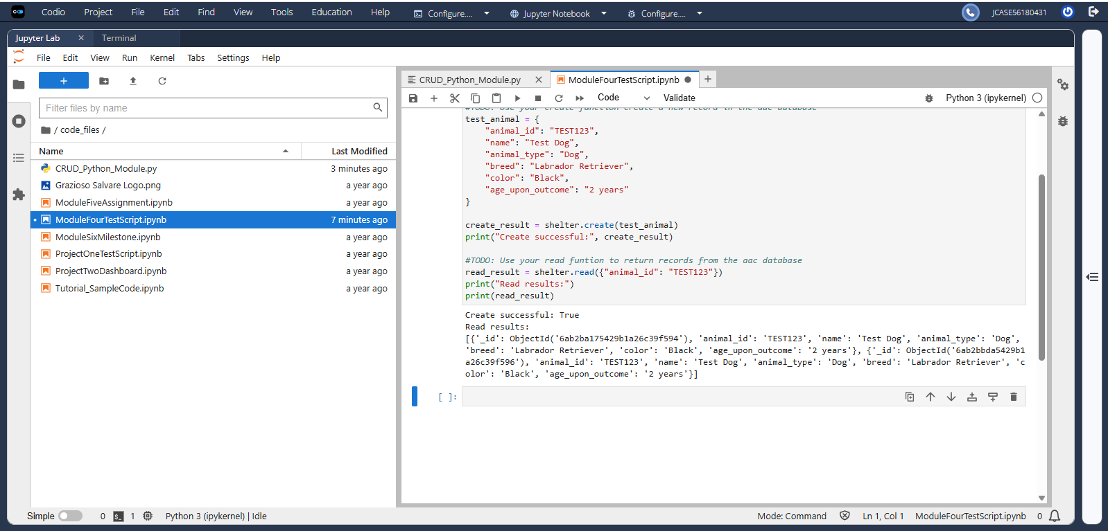
Figure 1 demonstrates the successful execution of the Python testing script. The script imports and instantiates the AnimalShelter class, successfully inserts a test document using the Create method, and retrieves the document using the Read method.

CRUD Python Module
Figure 2. Create and Read Methods
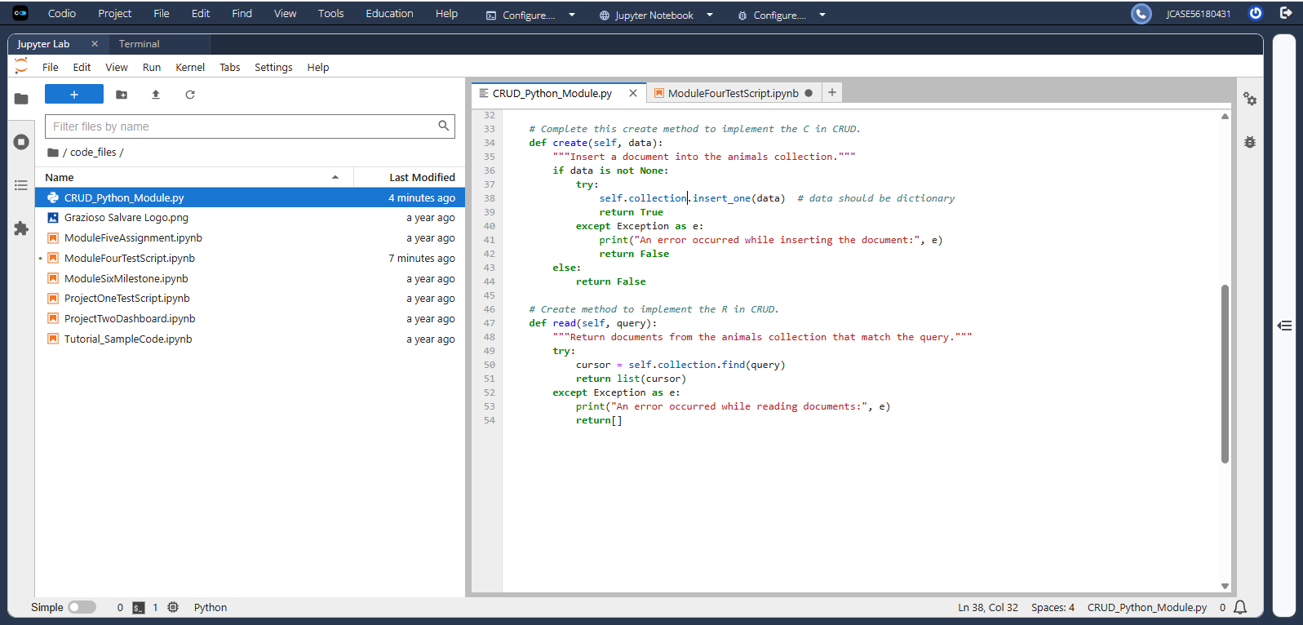
Figure 2 shows the Create and Read methods implemented in the AnimalShelter class. The Create method inserts a document and returns a Boolean result. The Read method uses MongoDB’s find() method and converts the returned cursor into a Python list. Both methods include exception handling.

